How Perforce Works
Perforce is an enterprise version management system in which users connect to a shared file repository. Perforce applications are used to transfer files between the file repository and individual users' workstations.
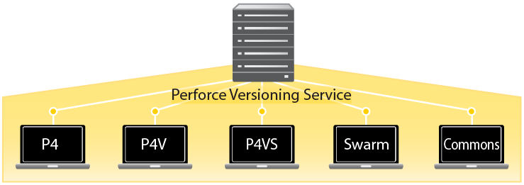

The Perforce Versioning Service
The Perforce versioning service manages shared file repositories, or depots. Depots contain every revision of every file under Perforce control. Perforce organizes files in depots into directory trees, like a large hard drive. Files in a depot are referred to as depot files or versioned files. The service maintains a database to track change logs, user permissions, and which users have which files checked out at any time. The information stored in this database is referred to as metadata.
